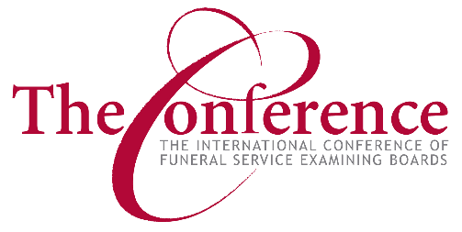

Dear Fellow Funeral Service Regulators, Educators, and Licensees:
On behalf of The Conference Board of Directors, I am pleased and honored to welcome you to the 120th Annual Meeting of The International Conference of Funeral Service Examining Boards! Your Conference Board and staff have worked hard to provide the very best in programming that we feel will benefit funeral service regulators, educators, and licensees. I know you will not want to miss any of this outstanding programming, but please leave some time to network with colleagues from around the country. We hope you will explore the wonderful accommodations at the Marina Inn at Grande Dunes as well as experience some of the “Southern Hospitality” Myrtle Beach has to offer!
The staff has been busy this past year, implementing programs that enhance our relationships with the member states and provinces we serve. Not only does The Conference provide guidance to these regulatory groups when requested, but we also supply materials and guides that share a wealth of information. Our newest publication, “Model Disposition Standards,” is available to access at the registration desk. It promotes clarity and uniformity in laws on Right of Disposition, as well as the licensing and regulation of individuals and facilities carrying out the final disposition of human remains.
To enhance the exam experience, we developed and implemented a Candidate Portal, as well as a requested Exam Voucher System for Mortuary Programs. Our Board Members and staff have worked to provide education about the NBE, and are happy to have shared with several groups this year, including mortuary schools, funeral associations, and state associations. We value their input, and appreciate the opportunities for communication.
Last, but not least, my heartfelt thanks to our Board Members, all of the dedicated committee members that volunteer their time to make The Conference what it is today, and especially our wonderful staff in Fayetteville, Arkansas! I feel truly blessed to have met so many of you these past years. I look forward to seeing you and again, my thanks for your support.
Best Regards,
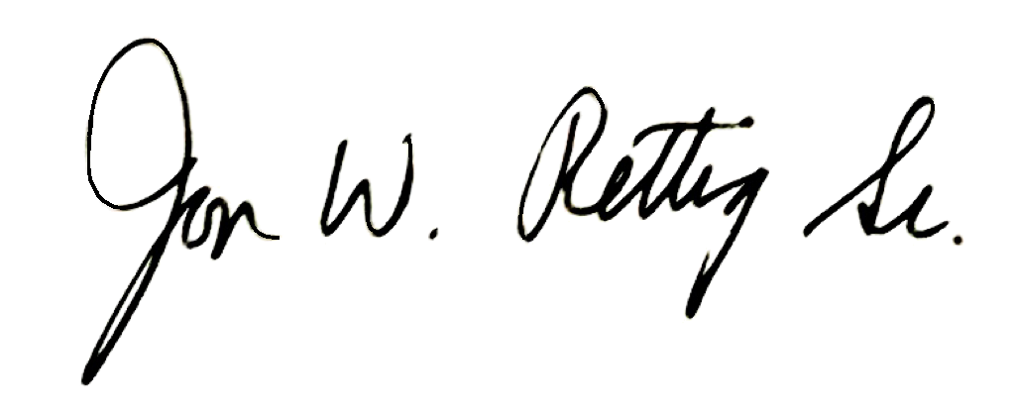
Jon W. Rettig, Sr., President
ICFSEB

